3.59: a) In Eq. (3.27), the change in height is 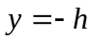. This gives a quadratic equation in x, the solution to which is
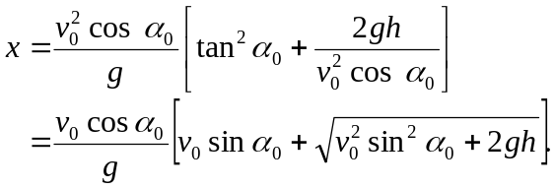
If 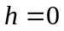, the square root reduces to 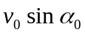, and 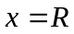. b) The expression for x
becomes
The angle 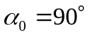 corresponds to the projectile being launched straight up, and there is no horizontal motion. If 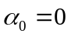, the projectile moves horizontally until it has fallen the distance h.
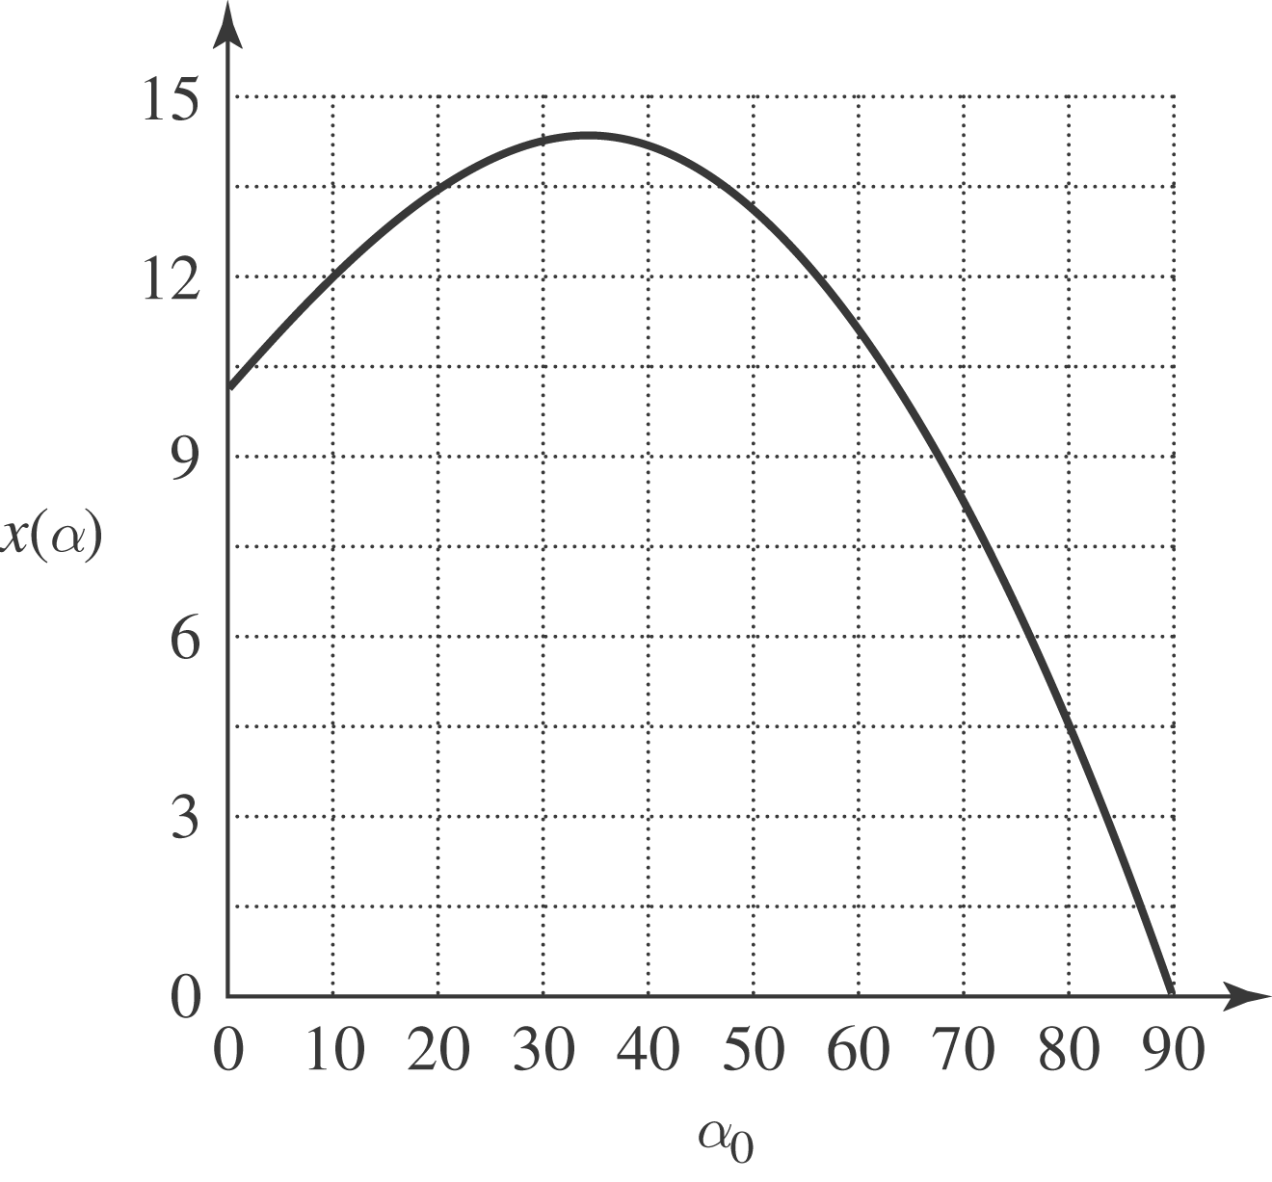
c) The maximum range occurs for an angle less than 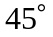, and in this case the angle is about 

